## 🧑‍💻 Section 1: User Management (1–15)

- Create a normal user named `user10`.
- Create another user named `user20` with a specific UID.
- Verify that both users exist in the system.
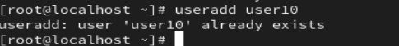

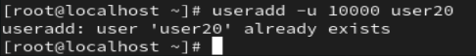
- Check the UID and GID of `user10`.
- Set a password for `user10`.
- Force `user10` to change the password at next login.
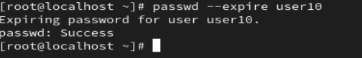
- Lock the account of `user20`.
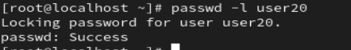
- Verify whether `user20` is locked.
- Unlock the account of `user20`.
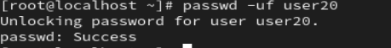
- Change the login shell of `user10`.
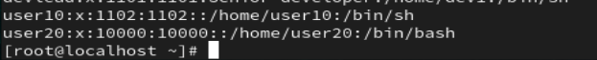
- Add a comment field to `user20`.
- Rename `user10` to `user_one`.

- Verify that the UID remains unchanged after renaming.
- Check the home directory of `user_one`.
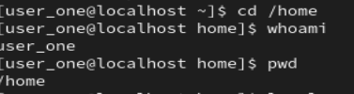
- Delete `user20` without removing its home directory.

---

## 👥 Section 2: Group Management (16–25)

- Create a group named `groupA`.
- Create another group named `groupB`.
- Add `user_one` to `groupA`.
- Add `user_one` to `groupB` as a secondary group.
- Verify group membership of `user_one`.
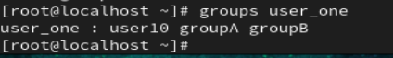
- Change the primary group of `user_one`.

- Remove `user_one` from `groupB`.
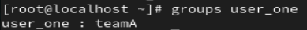

- Rename the group `groupA` to `teamA`.


- Verify the new group name exists.
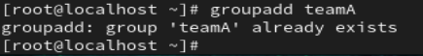
- Delete the group `groupB`.
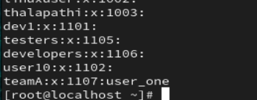

---

## 📁 Section 3: Directory Operations (26–35)

- Create a directory named `project`.
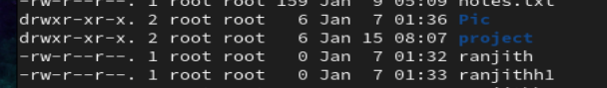
- Inside `project`, create directories `src`, `bin`, and `logs`.
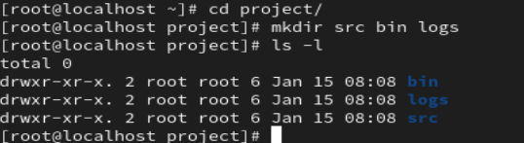
- Navigate to the `src` directory.
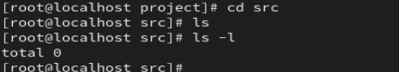
- Move back to the `project` directory using a relative path.
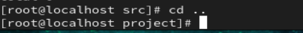

- List all directories in detailed format.
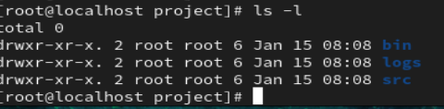
- Create a nested directory structure `data/input/raw`.
- Verify the complete directory tree.
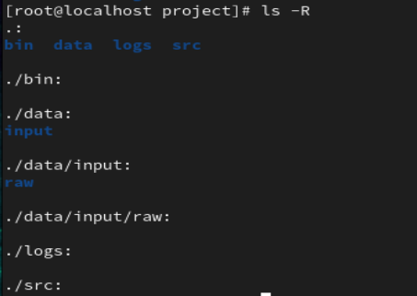
- Attempt to remove a non-empty directory using `rmdir`.
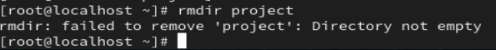
- Remove an empty directory using `rmdir`.
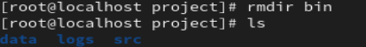

- Remove the entire `project` directory recursively.
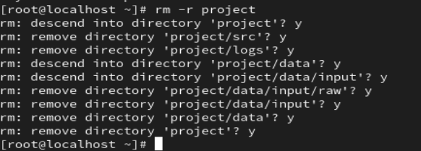
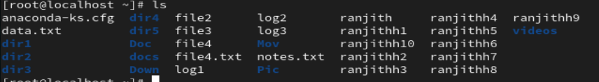

---

## 📄 Section 4: File Operations (36–50)

- Create a file named `fileA.txt`.
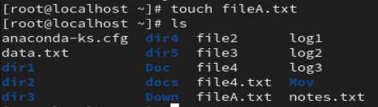
- Create multiple files `fileB.txt`, `fileC.txt`, and `fileD.txt`.
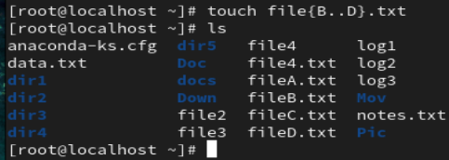
- List all files including hidden files.
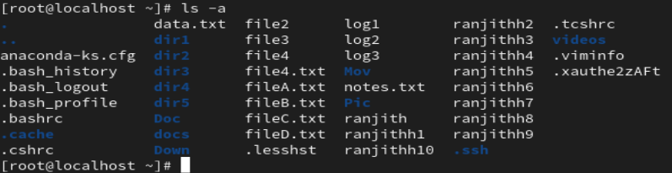
- Display file details using long listing format.
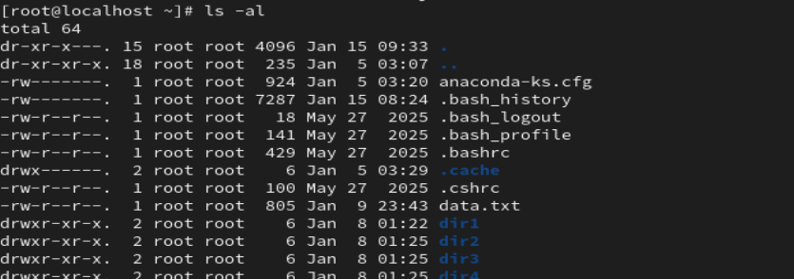

- Copy `fileA.txt` to `fileA_backup.txt`.

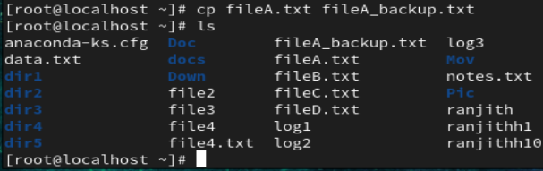
- Move `fileB.txt` to another directory.
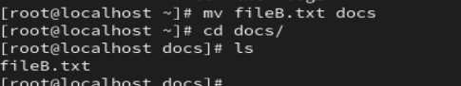
- Rename `fileC.txt` to `fileC_old.txt`.
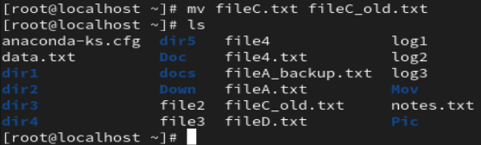
- Delete `fileD.txt`.
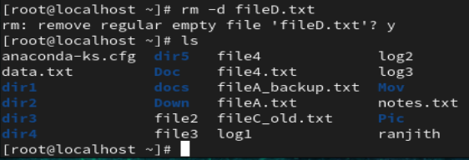
- Attempt to delete a directory using `rm` without options.
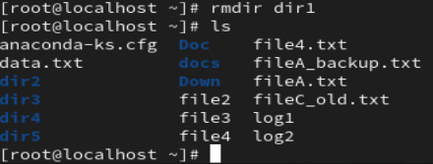
- Delete a directory using recursive remove.
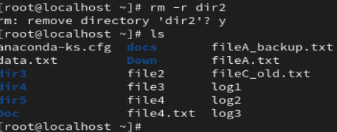
- Create a file and update its timestamp.
- Verify file size and modification time.
- Remove multiple files using a single command.
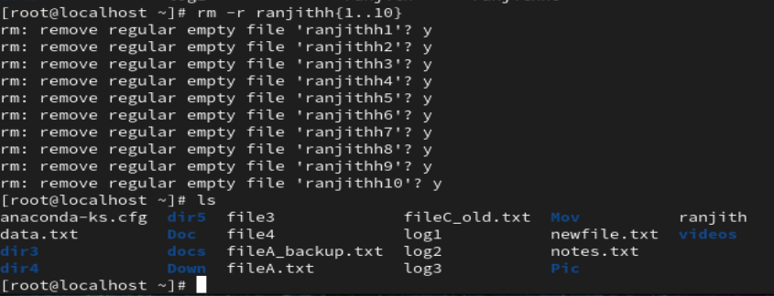

- Recreate deleted files.
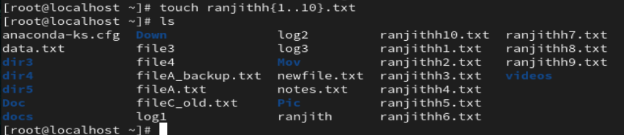

- Verify which files currently exist.
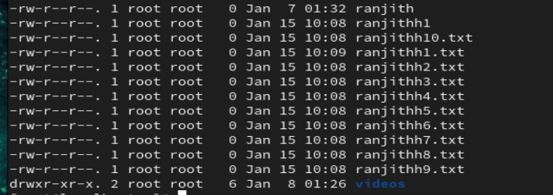

---

## 📖 Section 5: File Viewing Commands (51–60)

- Create a text file named `notes.txt`.
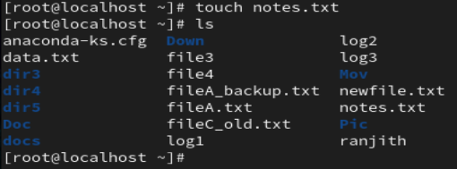
- Add at least 10 lines of text to `notes.txt`.
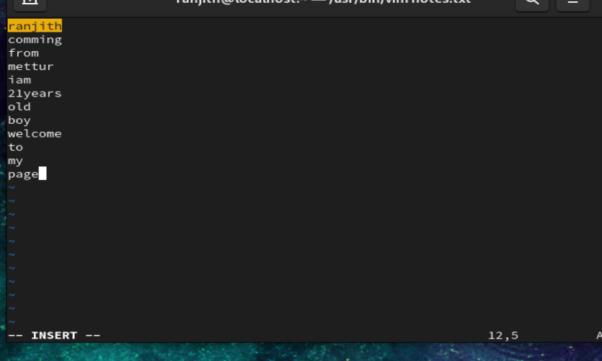

- Display the entire file using a single command.

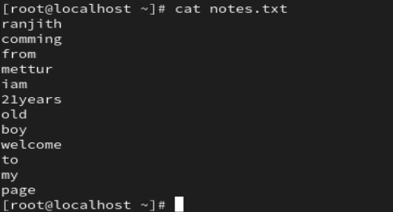
- Display the file with line numbers.
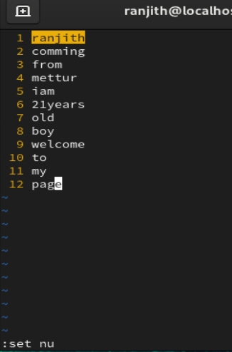
- View the file using a paging command.
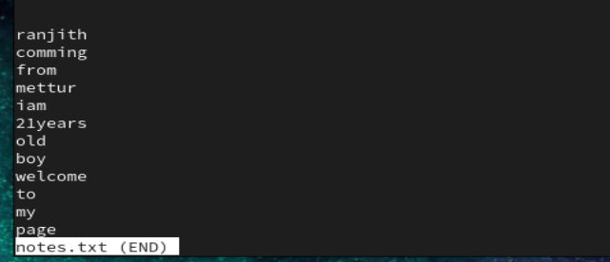

- Exit from the paging view.

- Display only the first 5 lines of the file.
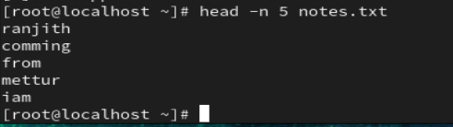
- Display only the last 5 lines of the file.
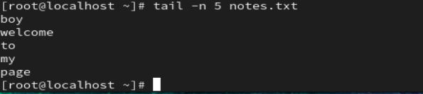
- Append additional lines to `notes.txt`.
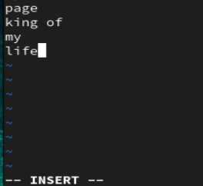
- View only the newly added lines.
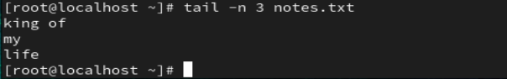

---

## 🔍 Section 6: Navigation and Information (61–70)

- Display your current working directory.
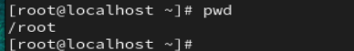

- Navigate to your home directory using a shortcut.
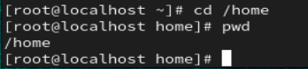
- Navigate to `/etc` using an absolute path.
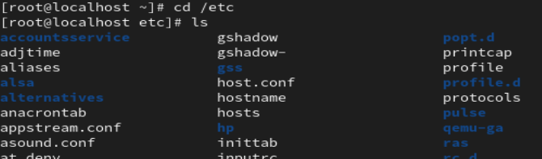
- Return to the previous directory.
- Identify the difference between absolute and relative paths.
Absolute path
cd /home/ranjith/Downloads
step by step moving the directory in single command
source to destination also implemented in the same command.

Relative path
cd ../Pictures
shift to one directory to another directory to moving or moves you up one directory level
- Display the currently logged-in users.
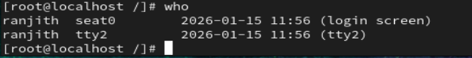
- Display only your username.
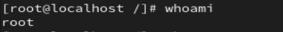
- Check login history of the system.
- Verify users with UID greater than or equal to 1000.
- Cross-check user information from `/etc/passwd`.
